COLORADO RECORDER RALLY with MATTHIAS MAUTE
Featuring Matthias Maute,
Virtuoso recorder soloist/Flautist/Conductor/Composer
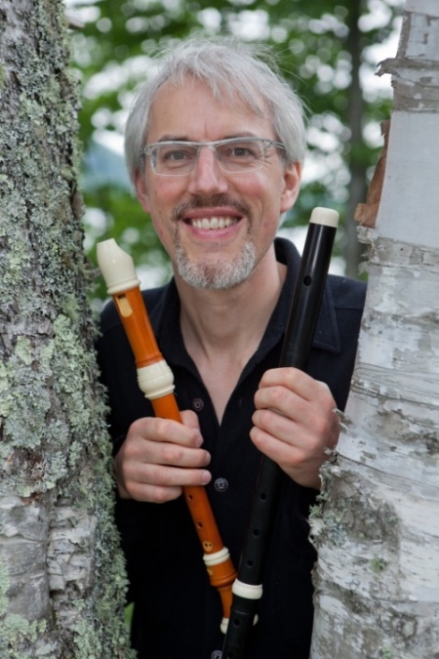
Sunday, September 9, 2018 1:30 – 7:00 p.m. Claver Auditorium, Regis University
Workshop: 2:00 – 4:00 pm, directed by Matthias Maute
Concert performance: 5:00 pm, conducted by Matthias Maute
Reception following concert
COST: $40.00 Includes workshop, performance, 1 guest concert ticket, and reception.
GENERAL ADMISSION: $20.00. Certain discounts apply.
PREPARATION REHEARSAL: Saturday, August 25, 9:30 a.m. – 12:00 p.m. St. Ambrose Episcopal Church, 7520 South Boulder Road, Boulder. Free.
MUSIC: Participants will perform a recorder concerto composed by Matthias Maute for the ARS Recorder Rally, a suite from Banchetto Musicale by Johann Hermann Shein, and Fantasia on a shape-note hymn by Eric Hass, the ARS 2018 “Play the Recorder” composition.
REGISTRATION FORM: Available at coloradorecorderorchestra.org (under Calendar) and denverrecordersociety.org

Sponsored by the American Recorder Society, Colorado Recorder Orchestra, Denver Chapter American Recorder Society, Regis University, and Conseil des arts et des lettres du Québec
